Field Research

How does a gymnast learn new movements?

How does a good visual feedback look like?
- from the view of a coach?
- from the view of an athlete?
- from the view of a psychologist / human movement researcher?

What Information does a gymnast/trainer want from the visual feedback?

What function does the feedback have?

How has the System to be designed to fit in the training environment?

Methodology

Direct and participant observation

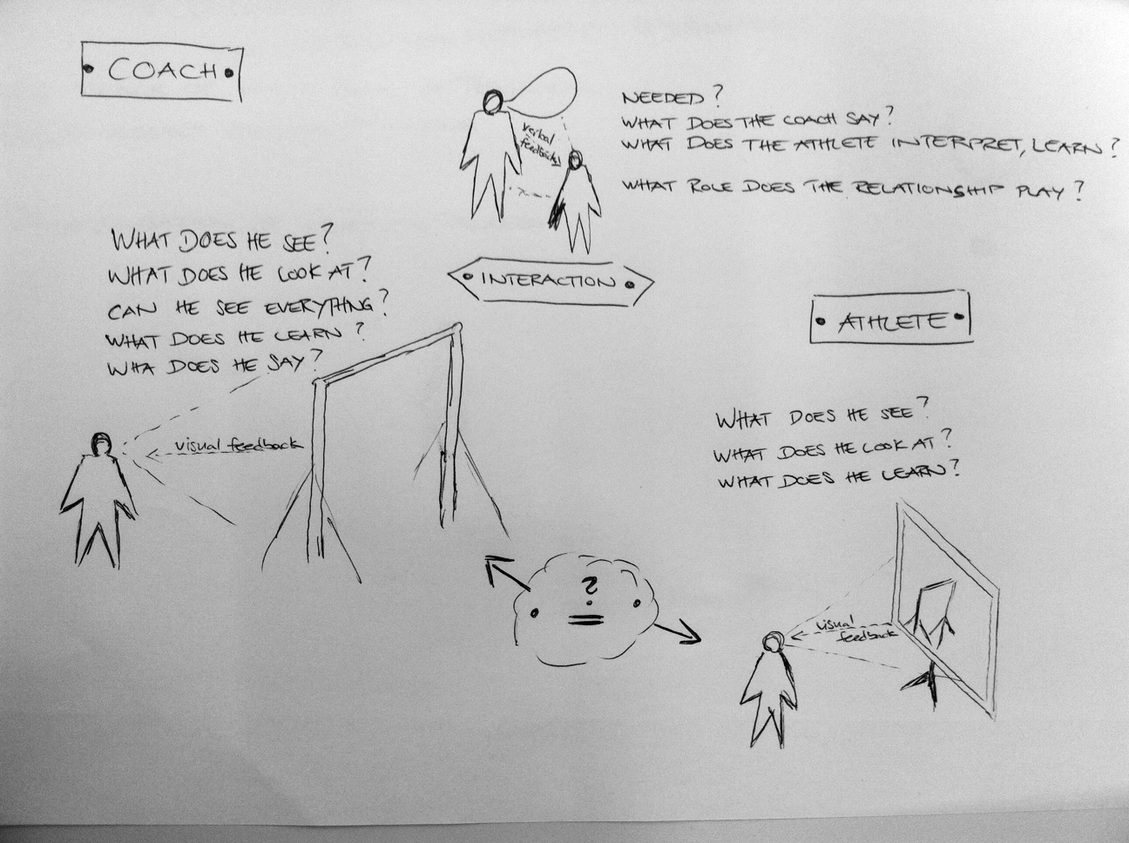

Firstly, I want to observe the training only. Especially the interaction between coach and athlete and all the different feedbacks should be observed and analysed. In a second step I’d like to involve athletes and coaches and ask them about their view on this topic. I’m going to discuss the filmed scenes with either the coach, the athlete or both at the same time.

These observation I’d like to do in a professional environment as well as in an amateur one, so that I can compare those two different areas and find out, whether there are problems which can be solved and what that problems are.

Tasks:
- find amateur sports club to go to and observe and film training
- find out on what time of the year the gymnasts in magglingen are learning new elements

A second area of observation is the time and environment outside the training environment! Especially in the case of the trainer it still is part of his job as a trainer since one part of his job is happening outside the training.

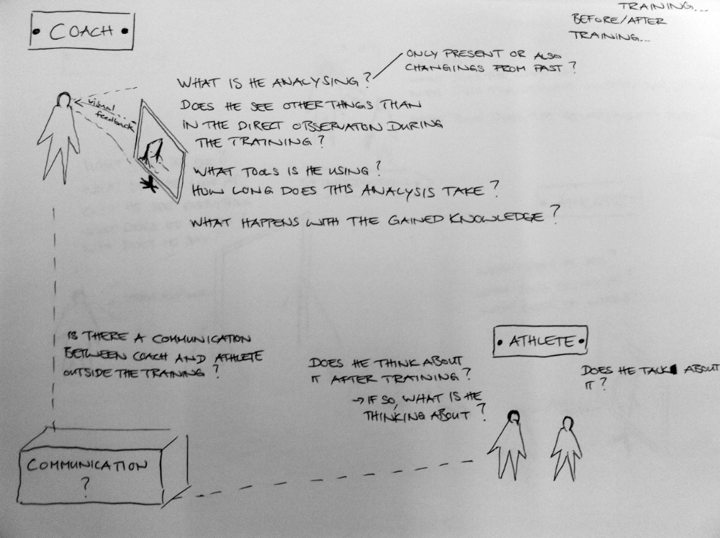

My main goal is to discover whether there is room for improvement in the analysis of movement outside the training environment. Therefore I wanna discover how the relationship between coach and athlete is and if they communicate with each other after the training.

